Automatic Pesticide Sprayer Bot

Chetan Shinde¹, Akash Shekhavat², Ajinkya Sathe³ ,Shripad Bhatlawande³
^{1,2,3}Vishwakarma Institute of Technology, Pune - 37
Abstract. Pesticide spraying is a necessary activity in agriculture to get more yield and to protect our crops from weeds, insects and fungus. As a result, manual pesticide spraying is practiced in most parts of India. Manual spraying results in direct contact with pesticides which give birth to numerous health problems including severe diseases to farmers. As a part of the solution, we propose an Automatic pesticide sprayer. Using this bot farmers will be able to spray pesticides remotely without any physical contact during spraying. Generally, more than one person is involved in manual spraying but using this bot single person can operate spraying activity using a mobile application remotely.
Keywords: Pesticide spraying, Automatic spraying, Agriculture, Manual Spraying, Pesticides.
- Introduction
Agriculture is one of the huge and important sectors which fulfills food requirements of the world. Agriculture involves different activities in which pesticide spraying is major one. Farmers used to spray pesticide to protect their crop from insects, weeds, fungus and from many other diseases. Due to lack of cheap technology available for pesticide spraying majority of farmers using traditional spraying methods i.e., manual pesticide spraying. This traditional method is not only time consuming but also hectic, inefficient at the same time. In manual spraying farmers takes heavy pesticide loaded tanks on their back and they have to spray all day into the grown farms. This increases the difficulty of spraying for farmers. In manual spraying farmers are exposed to the poisonous pesticides which are hazardous to both farmer’s life as well as for working labors.
According to many studies done worldwide on farmers affected by exposure to poisonous pesticides the casualties are in thousands. The exposure to those poisonous pesticides causes many diseases like skin diseases, eye irritations, respiratory diseases and even leads to cancer [2]. These all practices are done due to less availability of cheap spraying technologies for contactless spraying. The automatic pesticide sprayer bot that we propose can be solution for all those problems faced by the farmers. This bot can be operated from long distance over Wi-Fi technology which will insure the contactless spraying. This bot itself will be able to spray into the crop which will be operated by the farmer at a distance. Bot has two spokes wheels, a tank for pesticide, a dc water pump, high torque dc motors, lithium ion battery, ESP8266 Wi-Fi module, motor driver. The communication between the operator and the bot will be done over Wi-Fi which has range up to 8 to 10 meters.
- Literature Review

Technology is the need of today’s world. Every sector is growing by introducing modern technologies to their work and enjoys high efficiency and huge profit. Similarly, agriculture also takes foot forward in using new technologies in its agricultural work [2]. It is also a sector that requires huge labor and intense physical work. Technology is the thing that can change the face of agriculture forever [3]. Agriculture means practicing numerous practices, right from sowing the seed to cutting the crops. Pesticide spraying is one of those activities that is so hectic, inefficient, and hazardous.

Advanced and expensive technologies are unaffordable to common farmers, and they require cheaper equipment with well-equipped technology. 80% of farmers use the traditional spraying method for pesticide spraying [5]. Traditional spraying involves direct contact with hazardous pesticides. While performing activities like mixing, loading, spraying, and cleaning spray pumps farmers get chronic intoxication. Which can cause chronic diseases like skin cancer, respiratory diseases, multiple basal cell carcinomas, and squamous cell carcinomas [6]. The farmers feel fatigue and dizzy or have headaches because of the constant manual spraying [7]

Technology is the need of today’s world. Every sector is growing by introducing modern technologies to their work and enjoys high efficiency and huge profit. Similarly, agriculture also takes foot forward in using new technologies in its agricultural work. It is also a sector that requires huge labor and intense physical work. Technology is the thing that can change the face of agriculture forever. Agriculture means practicing numerous practices, right from sowing the seed to cutting the crops. Pesticide spraying is one of those activities that is so hectic, inefficient, and hazardous [2].

Advanced and expensive technologies are unaffordable to common farmers, and they require cheaper equipment with well-equipped technology [3]. 80% of farmers use the traditional spraying method for pesticide spraying. Traditional spraying involves direct contact with hazardous pesticides. While performing activities like mixing, loading, spraying, and cleaning spray pumps farmers get chronic intoxication. Which can cause chronic diseases like skin cancer, respiratory diseases, multiple basal cell carcinomas, and squamous cell carcinomas [2]. The farmers feel fatigue and dizzy or have headaches because of the constant manual spraying.

The insects and pests are living under the crop’s leaves, it is difficult and hard labor to spray under the leaves of the crop. These results in reduced yields, lowered quality, and damaged plants or plant products that cannot be sold. In this paper, the aim is to design and develop an autonomous pesticide sprayer for the chili fertigation system. In chili fertigation farms, pests such as mites, snails, and maggots are a common type of pest that can be found in this farm by making the plants as their source of food and breeding ground. Normally, the worker needs to manually spray the pesticide while wearing protective gear and walking from crop to crop. This method indeed inefficient practice and hazardous chemicals used in spraying can be fatal to the worker even wearing protective gear because research conducted found that the protective gears do not stop the chemical but only reduce the amount of exposure. Further, the study is intended to implement a flexible sprayer arm to spray the pesticide under the crop’s leaves, respectively.[4]

In this paper, the purpose was to know the health impact of pesticide from pesticide using methods of spraying by the workers and farmers in Sumber Mufakat village Kabanjahe Karo. This is an analytical survey with cross sectional design to find out the health impact from pesticides sprayed work farmers method. This research concluded that there was a significant relation between pesticide using methods with health impact. Recommended for the sprayed worker farmer to protect themselves by using safety equipment to avoid the direct exposure from pesticide. [5]

In India, nearly 70% of people are dependent upon agriculture. So, the agriculture system in India should be advanced to reduce the efforts of farmers. In this paper, a robot is made for spraying pesticides on farms and its main task is spraying pesticides in the irrigation system. The whole robot is designed on a four-wheel car base mechanism and controlled through remote switches. This robot worked on a 33V (12+12+9) DC battery. Pesticide level indicator is also included in it. This is for indicating a pesticide level. The indicator is supplied by a 9V battery. The pesticide level is indicated by the L.E.D. This robot can work in any climate condition.[6]

A pesticide mixer which automatically mixes the pesticide and water in particular ratio and the mixer is automatically sprayed to the field on the programmed date with the help of PLC. Also soil moisture condition and water level is monitored using moisture sensors and ultrasonic sensors. If the soil moisture level is low or high, the transmitter RF sends a signal to the receiver RF and accordingly the motor is turned ON/OFF with the help of PLC. The PLC is programmed with the date and time for the automatic pesticide mixer operation. Manual mode is also included in case of emergency by switching ON even before the programmed date arrives.[7]

Multipurpose pesticide sprayer can also be seen in the market. A manually operated pesticide and fertilizer sprayer [8] can be effective for middle class farmers but it also adds the manual touch to pesticide spraying. So, this type of manual sprayer again makes the job worse for farmers.

Using CNC machine, a proposed Automatic Robot which can walk at any point of the plant for farming crops autonomously. Robot designed to be able to plant plants with solid media and dimensions of planting area that can be adjusted according to the needs [10].

Movement of the robot can be controlled using the PLC microcontroller. Using PID controller in the closed loop feedback of sprinkler motor for online flow control of spray, linear and automatic flow control can be obtained [11]. The automaticity of the bot can be increased by using lidar sensor. Plant detection, autonomous controlling and achieving autonomous spraying can be achieve by lidar [14].
- Methodology

The manufacturing of the bot is divided into three steps. In the first step, the rough model is created in tinker cad a 3D modelling software to ideate the design of bot. After that the final design is modelled in 3-D modelling software, in the second step the hardware components were selected according to the requirement of bot’s frame. Along with the hardware components electronics components were also decided and selection of power source was completed. In the third step includes the interfacing assembling the bot’s frame as per the 3D model and the software part is done in the third step.

A. 3D MODELLING
This is the first step of implementation, and the 3-D model of the bot is created using online software called Tinker cad. It is basic modelling software that provides the environment for simple and quick modelling of any object [Fig I]. This step includes two sub steps. In first sub step the rough design is created. Taking learnings from it the final 3D model is created with taking all the measurements into considerations. The final design is also modelled in the same 3D modelling software Tinker cad.

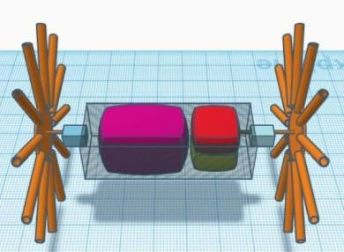

Fig.1 3D MODE

B. HARDWARE
Once the 3D model is finish and all the measurements are ready the hardware is chosen. Special attention is given on material selection. To avoid overweight of the bot, aluminium is main building material with plywood. We will require 6mm hollow aluminium pipes for the spokes of wheels. Each wheel will have 12 such pipes i.e., overall, we used 24 pipes for 2 wheels of the bot. We make use of 6 mm plywood for the container present between the wheels as it needs to be strong and rigid. We use a small 400ml tank for carrying pesticides. We use 50+ nut bolts to attach aluminium pipes to plywood. As a modification in the bot, we used T-shape connectors at the end of the aluminium rod which will be in contact with the ground. For spraying we use a 3mm pipe with a nozzle at the end.

C. ELECTRONIC COMPONENTS AND SOFTWARE

To get sufficient torque, we use 2 motors of 60 rpm each. Each motor can provide a torque of 2 kg-cm and draws a max load current of 300 mA. A 12V DC pump is used for spraying pesticides. Its working current is between 0.5 to 0.7A. Its power requirements are between 4W-7W, and its max water flow is in between 1-3L/min. the 2 channel LM298 series motor driver is used to run the DC pump and our main wheel motors. 12V li-ion batteries are being used to power up the whole assembly. For communication, we have use ESP 8266 Wi-Fi module. Its operation voltage is 3.3V.
We use a free online IoT platform called Blynk. It is available in both a web app and an android application. In this application, we use two sliders one for controlling the speed of the bot and another one for pump operation. Four buttons are used to set the forward and backward motion of the bot. We have added a joystick for better handling purposes. Arduino IDE is an Arduino Integrated Development Environment. After collecting all hardware components assemble them according to the 3-D model. We have two main parts made and those are wheels and containers.

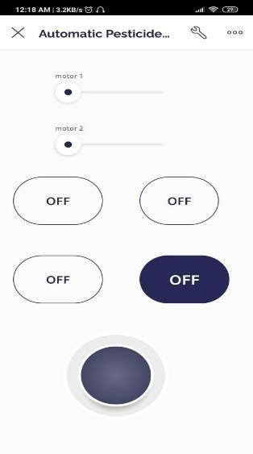

Fig.2 Blynk Software Console

- Wheel Dimensions

We made the wheel as it is a crucial part of the bot. Each wheel consists of 12 aluminium rods having a T-shape connector at the end of each wheel. The length of each aluminium rod is 24 cm from the ground. All Aluminium rods are Fixed with nuts and bolts to a 3mm plywood disc with a diameter of 18 cm. Rods are fixed such that they are 3 cm inside of the disc. Thus, after adding the length of the rod and disc we get the diameter of the wheel as 54 cm. 12 wheels were fixed on the circumference of plywood. The angle between the two aluminium rods is 30⁰.

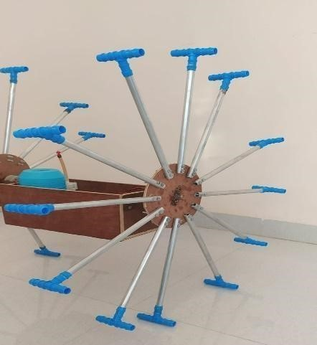
Fig. 3 Spoke Wheel Design

- Container Dimensions

The container is the part between the two wheels of the bot, and it will carry all the electronic components along with the pesticide tank and the DC pump. The container is a rectangular box of 29 cm in length, 12 cm in height, and a width of 14 cm. Its sizing is sufficient to hold a pesticide tank with a pump and all electronic components. [Fig.4]

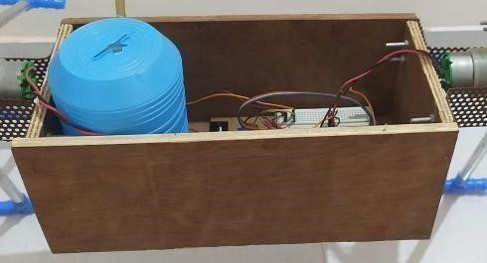

Fig. 4 Container with Electronic Circuit

- Communication with Bot

Once we have collected all components and manufactured all required parts the only thing, we are left with is programming our components and designing our UI in the Blynk console. By using Arduino IDE, we have done the programming of the ESP 8266 Wi-Fi module. On blynk, we have designed UI in which we have buttons and sliders to operate our bot [Fig II.]. Once we made all electronic components connections, we will be able to operate the bot with the blynk 8266 Wi-Fi module has Wi-Fi transceiver operation with the range between 2400-2484 MHz and it also supports TCP/IP communication stack and Wi-Fi security including WAP3 [Fig V].

Fig. 1. Schematic of the model

3.2 System Setup & Requirements
PERN stack is employed to construct the proposed system. PostgreSQL, React Express and Nodejs together make this PERN stack. It is stated to be a full stack application and uses JavaScript/Typescript as the language and mongo dB as the database. The application's front end is developed in the React. The package manager for installing and changing NodeJS packages is called NPM (Node Package Manager).

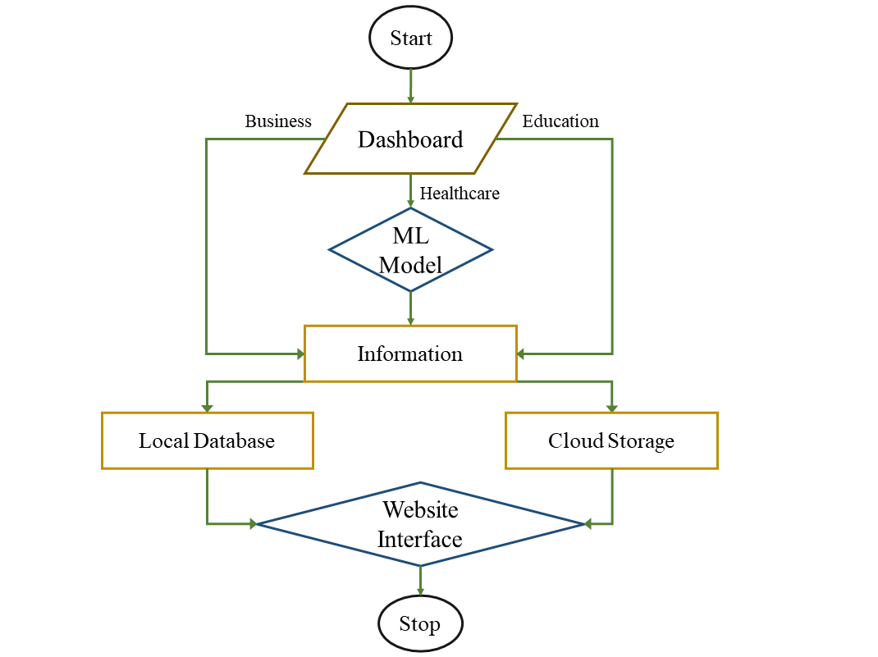
Fig. 2. Website Flowchart

When user first visit the website, he/she will be directed to the dashboard which further split into three modules (Fig. 3). User could access all the three components of smart city according to requirement. Each module gets directed to its own information where a user finds detailed information about the same. Information displayed is acquired from local storage or cloud server. Education sector is connected with PostgreSQL local storage where a user can access to all the academic details and curriculum. Healthcare module additionally contains a ML model where a user will obtain the predictive analysis regarding particular illness given users health.
PostgreSQL is used to create a one-to-one connection between user database and frontend. After initialization, all the significant dependencies, including express, nodemon, mongo dB, etc, were installed. Using the command "npm-init," which launches a NodeJS project, the backend development process officially began. was initially set up in both microservices (frontend and backend; link in results and discussion). The procedure involved setting up a cluster and creating an account on the mongo dB website.
A component library called MUI (Material UI) is used to build react components for the front end. To develop these components, reference is made to the MUI documentation. Redux is the choice that is selected to do the job of managing the application's overall state. A global store, reducer, and controllers are components of the global state management solution Redux. The creation of an authentication system was the following feature or task. We are utilizing firebase as the authentication system provider in order to simplify the codebase. We can integrate the application using Firebase's many capabilities and functionalities. From a UX standpoint, Google authentication is a feature that is crucial. Additionally connected with Firebase is Google authentication. Another feature offered by Google Firebase is cloud storage.

3.3 Module Descriptions
Business module is made which contains business related information. For storing all the business-related information, we have used mongo dB as the storage. The website provides users with Ads regarding to business and industries according to the users' demands. The platform allows customers to add their details for selling their products and real-estate properties. A brief information is provided for Industries and hubs with their location over the website. Axios which is the promised based http client for Java script is the library used for getting all the information related to the api from the News-Api website and storing them in them as objects in the articles. For showing the various information got from the api in a user presentable way we use react. Firebase connection is done to connect the two models and a successful login page is built.
The healthcare module facilitates a platform where a user can enter his health symptoms and receive a disease prediction related to it. A ML model which is cross-platform and uses a collaborative filtering as a tool for recommending respective Healthcare authority. Additionally, the module includes user information and all the data that is required for hospital visits. We created a MONGODB schema for it and utilized the primary and foreign key-based mapping to map the user.

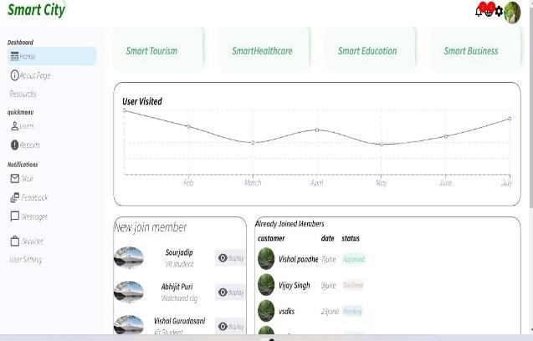
Fig.3: Website Dashboard
Education website does have a number of different pages, making it a multi-page website. PHP is employed in the login page's implementation. While the user tries logging in, PHP generates a database that is accessible. It verifies whether the user is present or not. An error message appears if the user credentials are incorrect. Once the user successfully logs in, a new session is started, and it lasts until the user logs off. The HTML and CSS used to design the website's front end are called Bootstrap and Sass. To improve the user experience, the interface has been kept straightforward and uncluttered. It is divided into categories like about, experience, contact, services offered, header, and footer. Every segment is a path to [2]. There is an urgent need for effective and practical health service app platforms that serve the elderly and young people to improve and promote smart health services Paper discusses concept of smart healthcare system and details regarding perception's design about an API's, particular HTML section element. Thus, accessing the website's many sections is simple for the user. The website's news page is made up of asynchronous communication between the website and the News API, which provides a variety of news. For retrieving the technological news, a unique API key is created. Form and form action are available on the register - contact page. The client side calls into and validates the PHP form. The PHP connects to a database with exam details after the form is submitted. This is displayed in a table's new route. The session is over when you click.
The website has been built as an interactive dashboard where user can enter increase their awareness and gain adequate knowledge for the interested domain. The user can easily reach out to the authorized persons through the contact details or the feedback and review section provided in the website.

4 Results and discussion
The administrator provides user the access to the Login and register on the page as seen in (Fig. 4.1). Main page includes information about local news, medical facilities, and business-related topics. The data will be managed and stored in the web page, being updated daily by the administrator. At first, the user needs to sign up on the page providing user information such as his or her user name, phone, address, email address, and secure password.

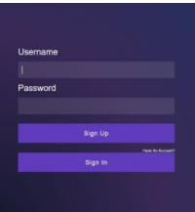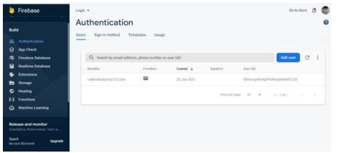
(a) (b)
Fig. 4.1: (a) Firebase login model (b) Firebase User Authentication system
The frontend implementation of the business model and its main portions are depicted in (Fig 5.1). The user can discover business possibilities and live business-related news from a variety of sources, before coming in the city. The platform aids companies and marketing agencies to display their products through Ads to increase their reach. The outcomes are evidence of proper news retrieval from the API, as shown in (Fig 5.2). The user can then make decisions based on the knowledge they have gained about the various hubs, trade, and industry. With this a user will get an understanding of how the business sector is thriving in the city.


Fig. 5.1: Front-page for business website


Fig. 5.2: Business News page
Based on the services offered to users, the E-healthcare systems are primarily divided into three types:
- People's access to e-health services and tools includes the ability to: - supply information through electronic health portals.
- In order to give users with health services rather than just electronic data like e-Prescriptions, Administration, and e-Results, administrative of E-Health support services and tools are administered for many individuals.
- ML model which recognises a particular illness based on symptoms.
All interfaces of the proposed website are shown within Fig(6.1 and 6.2)

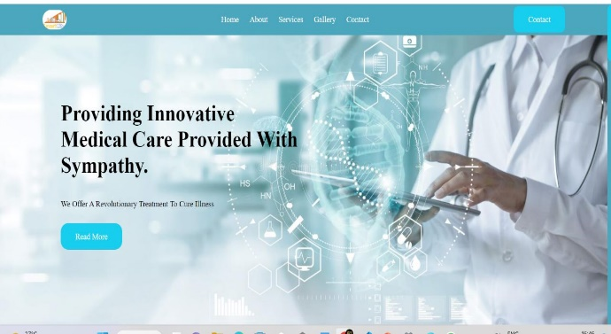
Fig. 6.1: Front-page for E-healthcare


Fig. 6.2: About us page for E-healthcare

The educational website is divided into various sub-components. The students can access the education website for School & College details in the city as shown in (Fig. 7.1). The students also have access to various free online platforms for books, lectures and blogs. A list for Olympiads, other important exams is provided. Additional news and institutional information can be acquired helping the students to get a preliminary understanding regarding educational environment of the city. The frontpage for the website can be seen in (Fig. 7.1).

Fig. 7.1: Interface for E-education

Login page for E-education is depicted in (Fig. 7.2) with query selection on PostgreSQL database.
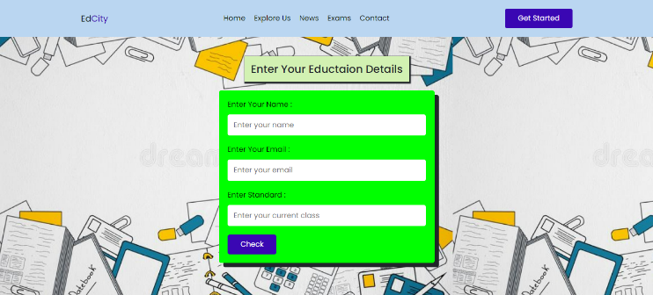
Fig. 7.2: Education Website Query Checking and Registration form

Various education sectors in city given a particular location is shown in (Figure. 7.3).
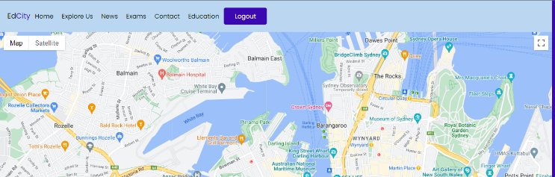
Fig. 7.3: Education sectors within a given location

5 Limitations
It is crucial to recognize the limitations and strive towards resolving them. The shortcomings of the system include the requirement for network connection. The system doesn’t cover all the required modules in smart city like Tourism. The ML model used can predict few diseases which is lacks in providing proper justification for the patients diseases. In the authentication system there is a lack of common identity verification for the citizens.

6 Conclusion
The key component of a smart city is to concentrate on numerous issues involving governments, companies, organisations for research, institutions, and hospitals in the
technical features of smart cities. Here, we advocate for the admin a better understanding, question residents about the situation and comprehension with citizens. After discussing smart city topic commonly with citizenries, researchers can find a more direct method to find pertinent. We have covered a lot of ground in this post on immigrants to a specific city, including information on the business, healthcare, and educational sectors. It will be a useful tool to acquire a comprehensive view of a given city. These smart city online applications are simple to use to obtain and comprehend information. Once the user register and provide their username, mobile number, and provide a good password to safeguard the data from others they are all set. The user can log in using their username and password visit the page wherever and anywhere they like. Such smart cities Applications improve and modernize folks' lives. The people can use this website to access any information about the city, including local news, organizations, and hotels. So accessing it is simple and sensible. Previously, whenever we travelled to unfamiliar locations, we would hire a guide, but today we don't need a guide to travel anywhere in the world. It is especially beneficial for students pursuing higher education given the locations of their universities and they are new in the locality.
More functionalities can be added to smart city web application like tourism, other locality description, food centres. Also, web scrapping and machine learning concepts like sentiment analysis and user recommendation based on user activities could be provided. Finally, implementation through mobile apps could be done to better increase the connectivity with the users. The prototype of the idea has been created and is a boon for people living in different cities.

Acknowledgment
A project execution always needs the cooperation, inspiration, direction, and support of many people. all of which were crucial to the success of this endeavour. We want to express our gratitude to everyone who helped the project along by assisting, guiding, and offering indirect support.

References
- Jog, Yatin, Ramamurthy Venkatesh, and Anubha Pandit, “Understan- ding Role of Mobile Apps in Smart City Services,” International Journal of u-and e-Service, Science and Technology, vol. 10, 2017.
- PPP (Public–Private Partnership) framework, SMARTAPPCITY, First App in India that brings together all city services, http://www.smartappcity.in/, (accesed Sept 2022).
- Heleen Bartlett, Head Director – Steve, AppCity supply schools and businesses with high quality apps, https://appcity.com.au/.
- Adams, A. Samantha, “Revisiting the online health information reliability debate in the wake of “web 2.0”: an inter-disciplinary literature and website review,” International journal of medical informatics, 2010.
- Kunttu, Iivari. “Developing smart city services by mobile application,” Proceedings of ISPIM Connects Ottawa, Innovation for Local and Global Impact, Canada, April 2019.
- Hu, Zhifeng, “Research on Big Data Application in Smart Education System.” 4th International Conference on Sensors, Mechatronics and Automation, Atlantis Press, 2016.
- P. Pallavi, K. Madhurank, “Smart education leads to a smart city,” International Journal of Advance Research in Science and Engineering, 2017.
- G. Sarin, “Developing smart cities using Internet of Things: An empirical study,” 3rd International Conference on Computing for Sustainable Global Development, New Delhi, India, 2016.
- Zhu, Z.-Ting, M.-Hua Yu, and P. Riezebos. “A research framework of smart education.” Smart learning environments, 2016.
- Singh, Harpreet, and Shah J. Miah, “Smart education literature: A theoretical analysis.” Education and Information Technologies, 2020
- Vervest, Peter, E. V. Heck, K. Preiss, and L. F. Pau, “Welcome to smart business networks”, In Smart Business Networks, Springer Berlin Heidelberg, 2005.
- Vm, Bhabad, Pankaj Nivrutti Varpe, Rajnandan Nitin Wale, Dhananjay Sunil Chaudari, and Tushar Bhausaheb Gadhave,”Online Smart Business,” Iconic Research And Engineering Journals, 2022.
- Langley, J. David, J. v. Doorn, Irene CL Ng, S. Stieglitz, A. Lazovik, and A. Boonstra. “The Internet of Everything: Smart things and their impact on business models.” Journal of Business Research, 2021.
- Mitchell, A. J. Davis, “Small business website development: enhancing the student experience through community-based service learning,” Journal of the Midwest Association for Information Systems, 2018.
- Marquardt, Katrin, “Smart services–characteristics, challenges, opportunities and business models,” In Proceedings of the International Conference on Business Excellence, 2017.
- Geetha, V., K. Keerthi, and N. Pavithra3 Dr CK Gomathy, “Smart City Using Web Development,” Journal of Engineering, Computing & Architecture, 2022.
- Tian, Shuo, W. Yang, J. M. Grange, P. Wang, W. Huang, and Ye Zhewei, “Smart healthcare: making medical care more intelligent,” Global Health Journal, 2019.
- Lalband, Neelu, and D. Kavitha, “Software engineering for smart healthcare applications,” Int J Innov Technol Explor Eng, 2019.
- Baker, B. Stephanie, W. Xiang, and I. Atkinson, “Internet of things for smart healthcare: Technologies, challenges, and opportunities.” Ieee Access ,2017.
- Solanas, Agusti, Fran Casino, E. Batista, and R. Rallo, “Trends and challenges in smart healthcare research: A journey from data to wisdom,” IEEE 3rd International Forum on Research and Technologies for Society and Industry, 2017.
- Jiang, Na, L. Wang, and Xinyu Xu, “Research on Smart Healthcare Services: Based on the Design of APP Health Service Platform,” Journal of Healthcare Engineering, 2021.
- Pohjola, Tiina, M. Suhonen, K. K. Mattila, and R. Meretoja, “The work done in healthcare projects." Journal of Nursing, 2016.
- Al-Kindi, Iman, and Zuhoor Al-Khanjari, “A Novel Architecture of SQU SMART LMS: The New Horizon for SMART City in Oman,” Third International Conference on Smart Systems and Inventive Technology, 2020.
- Joshi, Sujata, Saksham Saxena, and Tanvi Godbole, “Developing smart cities: An integrated framework,” Procedia Computer Science 93, 2016.

